Regional Quantity And Sales Using Radar Chart

Choosing Template

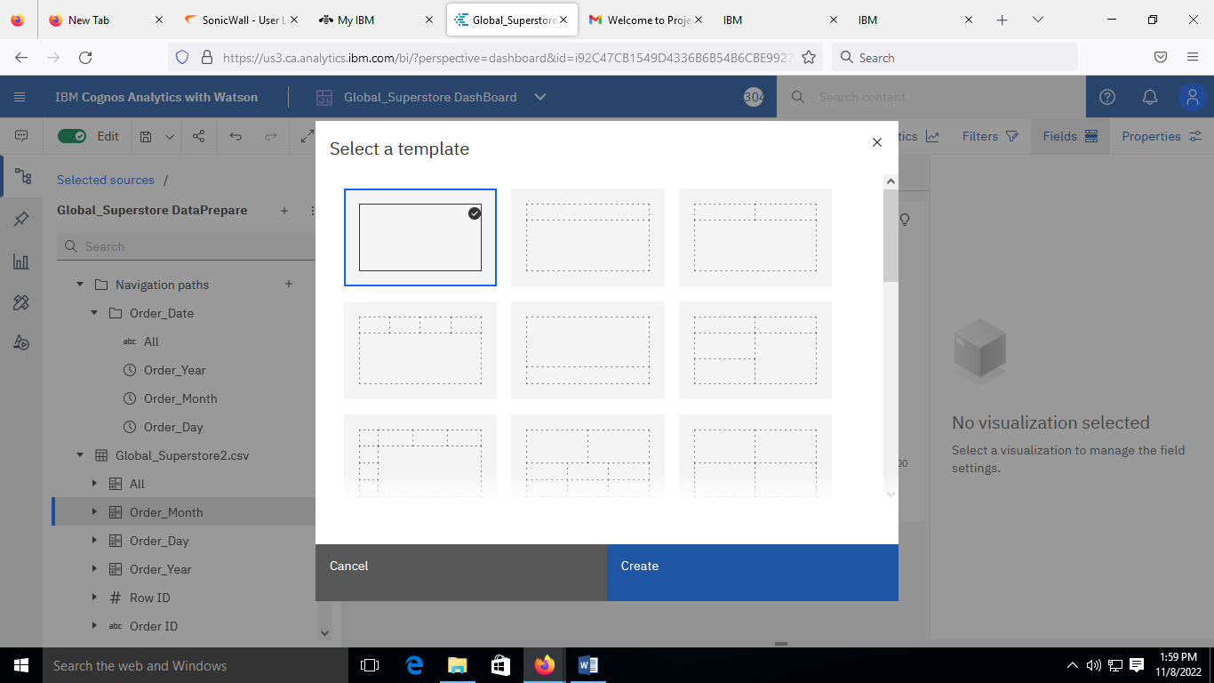

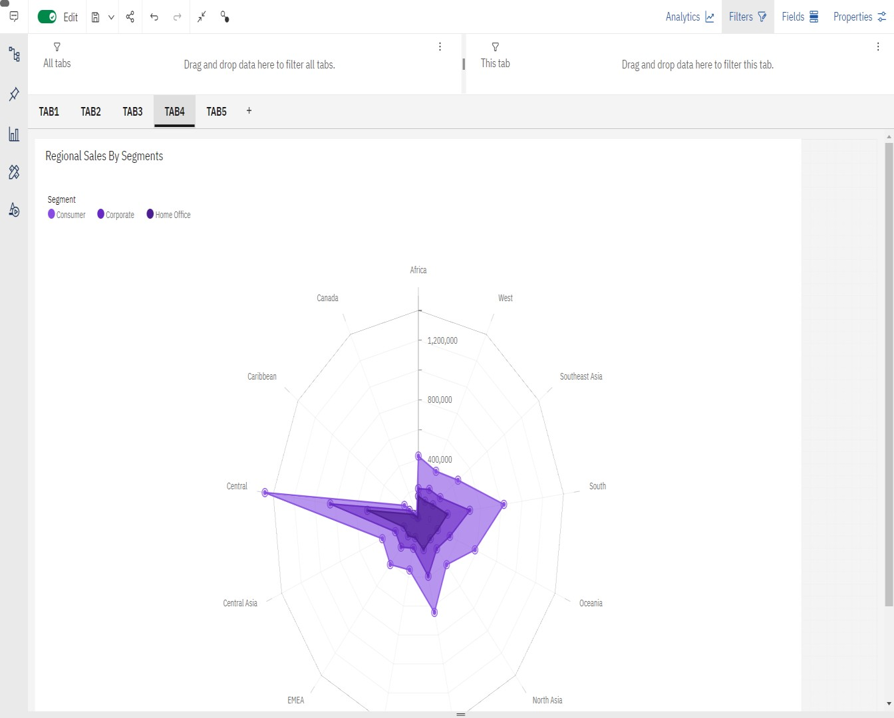Creating Visualization